UBC ATSC 303 2024/25W

Lab 8 – Anemometry (/65)

**Teaching assistant: Andrew Barnett (He/Him/His) | Kat Pexa (They/Them)**

**E-mail:** [abarn275@student.ubc.ca](mailto:abarn275@student.ubc.ca) | [Katrina.Pexa@ubc.ca](mailto:Katrina.Pexa@ubc.ca)

# Quick resources:

* How sonic anemometers work: Click here [(YouTube link)](https://www.youtube.com/watch?v=ZipwADWU_zI)
* How wind tunnels work: Click here [(YouTube link)](https://www.youtube.com/watch?v=L1AYo9Mk1EI)

# Learning Goals

By the end of this lab, you should be able to:

1. Design a calibration scheme for anemometers using wind tunnels.
2. Identify different instruments by their appearance.
3. Explain the physical and electrical set up needed to make these instruments work.
4. Understand how wind tunnels work.
5. Analyze wind data output from various sensors.

# Background

Harrison: Ch. 8

WMO (No.8) Guide to Meteorological Instruments and Methods of Observation Gill WindMaster sonic anemometer user manual

# Part 1 – Understanding how wind tunnels work – The Parkinson Wind Tunnel

The setup and experiment have already been done to you. The steps have been outlined below for your reference and to answer the subsequent questions.

Equipment:

* Parkinson Wind Tunnel
* Gill WindMaster sonic anemometer
* Kestrel weather station with propeller anemometer
* 12V battery power supply for sonic
* PC laptop with software for sonic data acquisition

The following figure display the positioning of the instruments inside the test section of the wind tunnel (the North arrow is aligned to the view wall):

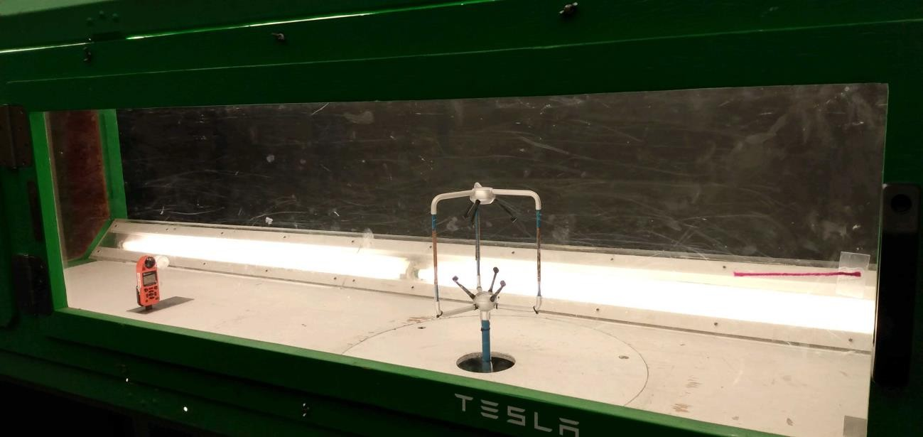

Procedure:

First with the sonic anemometer positioned at a lower height, each student will provide readings for the Gill instrument, Kestrel instrument, the Betz displacement (in mm) and a tentative reading from the chart provided in the wind tunnel spec sheet.

You can fill the readings in the following table during the lab:

|  |  |  |  |  |  |
| --- | --- | --- | --- | --- | --- |
| **Motor (rpm)** | **Gill (3D Sonic)** | | **Kestrel (m/s)** | **Chart (m/s)** | **Betz (mm)** |
| **U**  **(m/s)** | **V**  **(m/s)** |
| 200 |  |  |  |  |  |
| 225 |  |  |  |  |  |
| 250 |  |  |  |  |  |
| 275 |  |  |  |  |  |
| 300 |  |  |  |  |  |
| 325 |  |  |  |  |  |
| 350 |  |  |  |  |  |
| 375 |  |  |  |  |  |
| 400 |  |  |  |  |  |
| 425 |  |  |  |  |  |
| 450 |  |  |  |  |  |
| 475 |  |  |  |  |  |
| 500 |  |  |  |  |  |
| 525 |  |  |  |  |  |
| 550 |  |  |  |  |  |

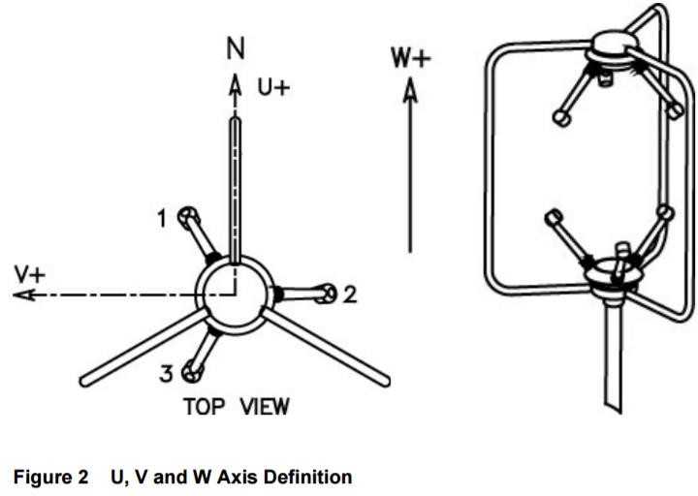

Next, we will adjust the height of the 3D Sonic anemometer and repeat the procedure. Use a new table for your recordings:

|  |  |  |  |  |  |
| --- | --- | --- | --- | --- | --- |
| **Motor (rpm)** | **Gill (3D Sonic)** | | **Kestrel (m/s)** | **Chart (m/s)** | **Betz (mm)** |
| **U**  **(m/s)** | **V**  **(m/s)** |
| 200 |  |  |  |  |  |
| 225 |  |  |  |  |  |
| 250 |  |  |  |  |  |
| 275 |  |  |  |  |  |
| 300 |  |  |  |  |  |
| 325 |  |  |  |  |  |
| 350 |  |  |  |  |  |
| 375 |  |  |  |  |  |
| 400 |  |  |  |  |  |
| 425 |  |  |  |  |  |
| 450 |  |  |  |  |  |
| 475 |  |  |  |  |  |
| 500 |  |  |  |  |  |
| 525 |  |  |  |  |  |
| 550 |  |  |  |  |  |

**Part 2 - Wind tunnel calibration of sonic anemometer (old data from 2015)**

The setup and experiment are done to you. The steps have been outlined below for your reference and to answer the subsequent questions.

Setup:

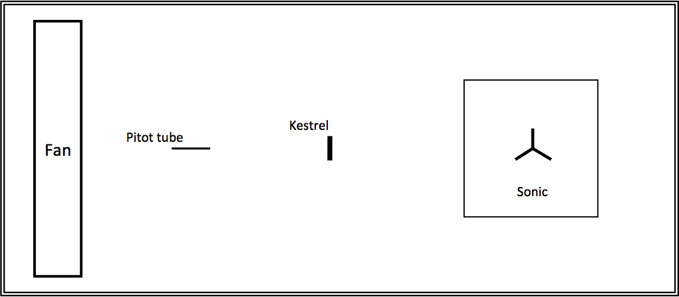

Equipment:

* + Boundary Layer Wind Tunnel
  + Pitot tube (for calibrated “true” wind tunnel speed)
  + Gill WindMaster sonic anemometer
  + Kestrel weather station with propeller anemometer
  + 12V battery power supply for sonic
  + PC laptop with software for sonic data acquisition
  + Duct tape
  + Weights

1. Set up instrumentation as shown in the diagram on the following page. Point north spar of sonic anemometer towards (perpendicular to) far side wall of tunnel. Secure instruments and mounting platforms using weights and duct tape so they are not blown over.
2. Set sonic and Kestrel to record automatically, at **10-Hz** and **0.5-Hz** frequency, respectively.
3. Increase wind tunnel rpm (revolutions per minute) from low to high in steps, taking two pitot tube readings at each step. Take first reading about half a minute after each rpm setting is reached (indicated by light on wind tunnel control panel), to allow increased wind speed to reach instruments downwind.
4. Rotate sonic 90 degrees so that North spar points towards the wind tunnel fan (parallel to the far side wall) and repeat step 3.

**Part 3 – Measurement of wind speeds in a lab setting (new data, from 2017)**

The setup and experiment are done for you. The steps have been outlined below for your reference and to answer the subsequent questions.

Equipment:

* + Gill WindMaster sonic anemometer
  + Kestrel weather station with propeller anemometer
  + 12V battery power supply for sonic
  + PC laptop with software for sonic data acquisition
  + Fan (High Velocity Air Conditioner, HVAC)
  + Duct tape
  + Weights/Rocks
  + Timer (clock or stopwatch)

1. Point North spar of sonic anemometer towards the fan. Secure instruments, mounting platforms, and the fan using weights and duct tape so they are not blown over.
2. Set sonic and Kestrel to record automatically, at **10-Hz** and **0.5-Hz** frequency, respectively.
3. Increase fan setting from **off** to **high** in steps (off -> low -> medium -> high). Take readings for 5 minutes after each setting is reached to allow increased wind speed to reach instruments downwind, and for the sensors to equilibrate to the new fan setting.
4. Decrease fan setting from **high** to **off** in steps (high -> medium -> low -> off)**.** Take readings for 5 minutes after each setting is reached to allow decreased wind speed to reach instruments downwind, and for the sensors to equilibrate to the new fan settings
5. Rotate sonic 90 degrees clockwise so that the North spar points perpendicularly to the fan and repeat steps 3 and 4.

# Lab questions (based on lectures, readings and data)

**Using old wind tunnel data (from 2023)**

* *Using the data file* ***PWT_new_readings_2023.xlsx:***

1. Using the Equation 1. Convert the Betz readings (in mm) to meters per second. Convert the U and V readings from the Gill instrument. Plot the velocity (in m/s) from all readings in a single plot. **/2**

Eq. 1: Air speed (m/s) = 4.03*(Betz)^1/2

1. Draw the flow pathways (streamlines) for each experiment through a lateral and top view **Hint:** think about zones of turbulence, boundary effects, propagation and flow deflection. **/6**
2. Discuss why the Gill 3D sonic anemometer measurements differ between experiments? (if it didn’t you should also be able to explain) **/2**
3. Based on the answers from 1) to 3), how the format of the sonic anemometer may affect the measurements? **/1**

**Using old wind tunnel data (from 2015):**

* + *Using data from the files* ***Kestrel_data.xlsx*** [data from Kestrel]**, *WindTunnelCalibration.xlsx*** [data from pitot tube as reference]***, 15031252_sonic.txt*** [sonic data, test 1]***,*** and ***15031254_sonic.txt*** [sonic data, test 2]**:**

1. Using the pitot tube wind speed as “truth”, perform a calibration on the:
   1. Kestrel,
   2. Sonic (test 1, north spar towards far side wall),
   3. Sonic (test 2, north spar towards fan).

**Plot the transfer curve**, write down the **transfer equation** and find the **calibration equation** for each. Explain how you averaged your data. HINT: See Lab 4 (Static calibration). Pitot tube measurements are the input values, and the Kestrel and Sonic are the output values. **/6**

1. Compute the **bias** for a, b, and c in question 2, using the pitot tube data as the reference measurement. Hint: See Lecture 5 on the definition of bias. **/3**
2. Is it possible to assess the dynamic performance of the Kestrel and sonic? Why?

**/2**

1. Is this experiment a full calibration of the sonic anemometer (in 2015)? Why? **/2**

# Using New Wind Data (from 2017):

* + *Using data from the files* ***\*\*\*.xlsx*** [data from Kestrel]**, *\*\*\*.txt*** [sonic data, test 1]***,*** and

***\*\*\*.txt*** [sonic data, test 2]**:**

1. Calculate the average **meteorological** wind direction for both cases. Note that the sonic anemometer has unusual definitions for the horizontal coordinates, as shown in the diagram below, so be sure to convert to the usual meteorological definitions of *U* and *V* before calculating the directions. **/2**
2. Compute the **time constants** for **both** the Kestrel and the sonic, for **two** scenarios: the fan setting going from **off** to **low** at the beginning, and from **low** to **off** at the end. Be sure to show how you computed them. **You will likely need to do some averaging to filter out the turbulent noise in the data sets…be sure to show how you did the averaging, and explain why. /6**
3. If you find that the time constants for a sensor differ between scenarios for that same sensor, explain why. **/4**
4. Which sensor do you think is more accurate? Why? **/2**
5. Which sensor do you think has higher resolution? Why? **/2**
6. How is this lab set-up different than the one done in 2015, with a wind tunnel? How does the presence of a wind tunnel change the flow properties of the air? Why could we not do a calibration this year, for 2017? **/3**
7. How can there be non-zero data values when the fan is off? What might be causing this? **/1**
8. How does the sonic sensor derive sonic temperature? **/1**

# Further questions (based on lectures and readings)

1. You are installing an anemometer on a weather station. The closest tree is 9 metres high. Ideally, how far should you site your anemometer from the tree, horizontally? What height above the ground should your anemometer be at? If you cannot satisfy these conditions, should you still take measurements? Why? **/4**
2. Sketch a graph of wind speed vs. time given the following data with proper labels and scales:

1 standard averaging time length

mean wind speed is 20 knots

one gust occurs at time = 1 minute

gust duration = 30 seconds

gust peak speed = 35 knots

gust magnitude = 25 knots

What is the gust amplitude? What is the lull speed? What is the gust frequency? **/8**

1. Can a cup anemometer overestimate a gust magnitude? How about a propeller anemometer? **/2**
2. Can a cup anemometer overestimate the mean wind speed in a gusty wind? How about a propeller anemometer? Explain. **/2**
3. Why does a propeller anemometer rotate faster than a cup anemometer? **/1**
4. If a cup anemometer in a wind tunnel takes 2.5 s to increase speed from 0.28 *VT* to 0.74 *VT* (*VT* = tunnel wind speed), what is the anemometer time constant? If *VT* = 6 m s-1, what is the response length? **/3**