**UBC ATSC 303 2024/25W**

**Lab 4 – Static Calibration and Dynamic Performance (/46)**

**Teaching assistant: Andrew Barnett (He/Him/His) | Kat Pexa (They/Them)**

**E-mail:** [**abarn275@student.ubc.ca**](mailto:abarn275@student.ubc.ca) **|** [**katrina.pexa@ubc.ca**](mailto:kpexa@eoas.ubc.ca)

**Quick resources:**

* Playlist “Fundamentals of CRBasic Programming”: [Click here (YouTube link)](https://www.youtube.com/watch?v=yBQCHf9XNT0&list=PLR_Ted9kITyJaTb0TtD_Cab9d9-sdryKf)
* CR1000x Datalogger (Part 1 of 4, make sure to watch all), Getting started: [Click here (YouTube link)](https://www.youtube.com/watch?v=Ch6MQWxR21E)
* ABC of Calibration: [Click here (YouTube link)](https://www.youtube.com/watch?v=SFOSEFp9yEU)

**Learning Goals**

By the end of this lab, you should be able to:

**Static Calibration**

1. Be confident in your handling of the physical sensors and software covered in this lab.
2. Use Excel spreadsheets to compute data statistics and create calibrated data.
3. Create the equations needed to propagate error for any sensor.
4. Reinforce the learning goals from the lecture and demo.

**Dynamic Performance**

1. Experimentally determine the dynamic response of a sensor given a noisy signal.
2. Explain how physical characteristics of a sensor affect its dynamic response.
3. Intercompare the static and dynamic characteristics of multiple sensors.
4. Write more sophisticated programs for data loggers.
5. Reinforce the learning goals from the lecture and demo.

**Background:**

Principles of Measurement and Instrumentation lectures (Static and Dynamic)

Harrison: Ch. 2

**Method**

**Part 0 – Powering the Datalogger and Connecting it to the Computer**

Equipment:

* CR1000 datalogger
* PC laptop with LoggerNet software
* 12V battery power supply
* Power adapter
* Serial cable
* Small screwdriver

1. With both the extension breaker and the Battery power output OFF, connect the Battery Charger to a power outlet. If you are connecting it directly to an outlet without the use of an extension, do Step 2 first.
2. Using a small screwdriver, connect the Battery Charger to the 12 V Battery. Turn the extension breaker ON.
3. Connect the Power Adapter to the 12 V Battery. **Red** wire to the 12 V port, **Black** wire to the Ground port.
4. With the laptop ON, connect the RS232 cable to the Datalogger in the correct port, and then to the computer (for Durabooks the RS232 port is at the back).
5. With everything connected, make sure to turn the Battery power output ON.
6. Open the LoggerNet software and proceed to connect the computer to the Datalogger. Make sure you upload the correct program. Your final setup should be similar to this:

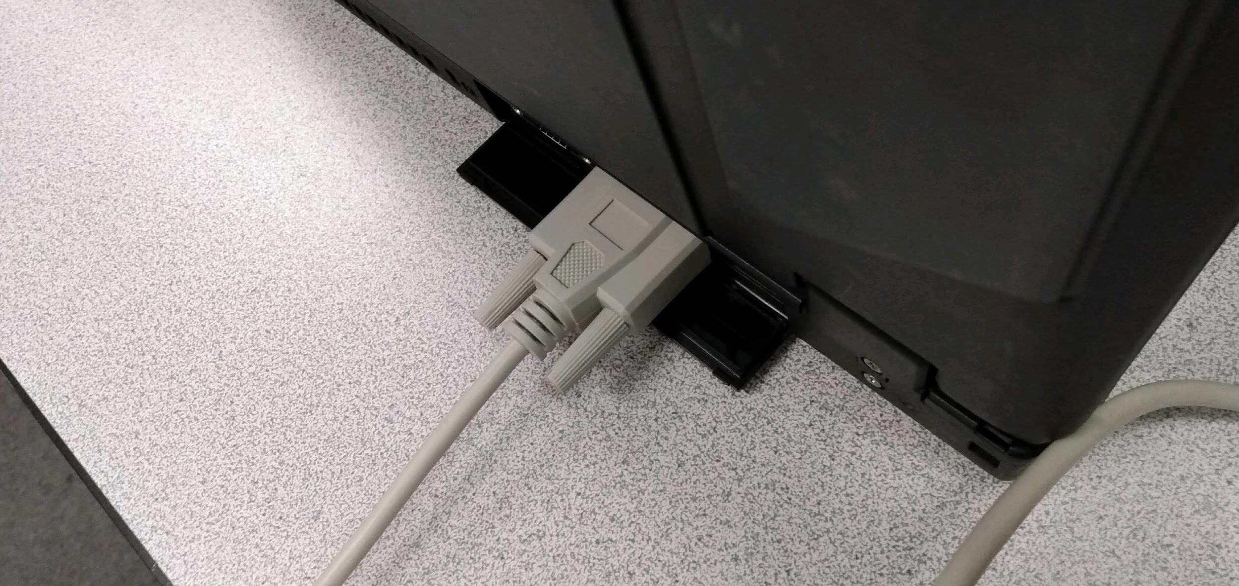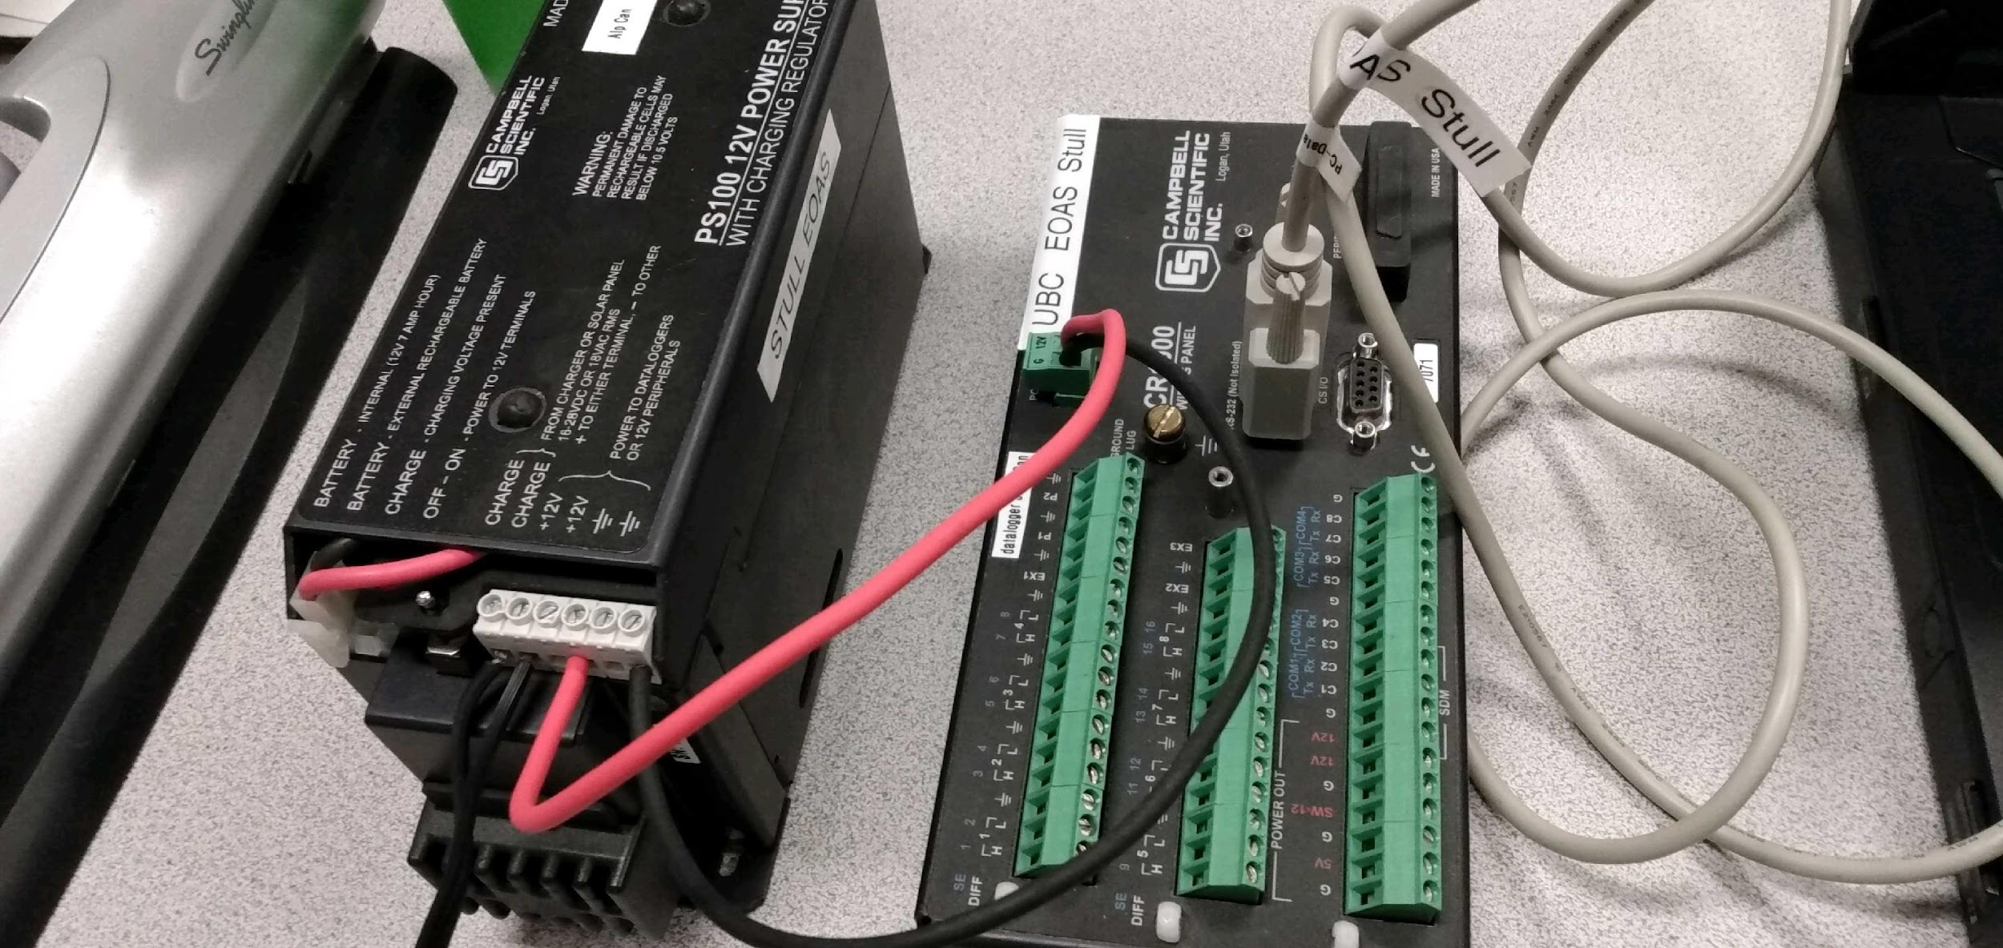

**Part 1 – Programming the CR1000 datalogger**

Equipment:

* CR1000 datalogger
* PC laptop with LoggerNet software
* 12V battery power supply
* Power adapter
* Serial cable

1. In LoggerNet, open up CRBasic. A template program is provided (lab4_static_dynamic_template_2025.CR1 on the Desktop). Fill in the blanks as follows:
   1. **Declare two variables** for each reference thermocouple temperature (two brown TCs). Call them something sensible that reminds you which differential channel they are connected to.

\**Helpful hint: read ahead to part 2 of this lab to find out which differential channels you will be using, and to get a better sense of why you are writing this piece of code.*

* 1. **Declare one variable** for the voltage difference across the thermocouple you are calibrating (purple TC).
  2. **Declare units** for all public variables.
  3. **Fill in the DataTable** with functions and their necessary parameters.

First, define the appropriate data interval using the *DataInterval* function. You should set Units to mSec, and Interval to be equal to 10 Hz (but don’t forget to convert to mSec).   
*\*Helpful hint: right click the function name to open a dialog box.*



Set TintoInt = 0, and Lapses = 10.

Next, you will be using the *Sample* function once for each thermocouple variable, with parameters given below:



Set Reps = 1, and DataType = FP2.

* 1. In the main program section**, declare your scan rate (sampling period) in ms.** We want output at a frequency of 10 Hz. Enter the number of milliseconds that this corresponds to.



Set BufferOption = 0, and Count = 0.

* 1. **Insert instruction for thermocouple measurement (in the main program): “TCDiff”** for the reference thermocouples and **“VoltDiff”** for the calibration thermocouple. You should be able to fill in the parameters **Destination, Differential Channel, and Thermocouple Type** yourselves. Set **Repetitions** = 1, **Voltage Range** = mV2_5C, **Temperature Reference =** Ptemp, **RevDiff** = True, **Settling Time** = 0, **Integration or fN1** = 250, **Multiplier** = 1.0, **Offset** = 0, where appropriate.





You should use *TCDiff* twice, and *VoltDiff* once.

* 1. Using the *CallTable* function, **call your data table** with the name that was defined for your table earlier in the DataTable function**.**

1. Save your program to the desktop as you go (**click “Save as…”**). Include the surnames of your group in the filename, and **do NOT overwrite the template** (others will use it after you). Compile your program, fixing any errors/bugs that occur.
2. Make sure your CR1000 has power and open the Connect screen. First click on “**Collect Now**”, then send your program to the datalogger. Your program should compile without any issues provided you already compiled it on the laptop.

**PROCEED TO PART 2 BELOW**

**Part 2 – Measurements for static calibration of Type E thermocouple; analysis of dynamic response to step input (one decreasing, one increasing) [assume the reference thermocouples were recently calibrated or are up to NIST standards]**

Equipment:

* CR1000 datalogger
* PC laptop with LoggerNet software
* 12V battery with power supply
* Power adapter
* Serial cable
* Small screwdriver
* 1 x purple Type E thermocouple wire (prepared for you)
* 2 x brown Type E thermocouples (again, prepared for you)
* Beaker for water

1. Connect the two brown Type E thermocouples (E1 and E2) to differential channels 1 and 2 on the datalogger. For both E1 and E2, make sure to connect the thin red wire to “L”, and the thin purple wire to “H”. These are your reference instruments or “knowns”.

*Note: E1 and E2 are the same type of thermocouple. To differentiate them so you can follow these lab instructions, note that E2 has extra tape wrapped around it (to increase its response time), and E1 only has thin tape.

1. Connect the purple wire, which has two junctions (J1 and J2), to differential channel 3 as demonstrated (J1 in “H”, J2 in “L”). This is the instrument that you are calibrating. See the conceptual diagram below to get an idea of what is happening.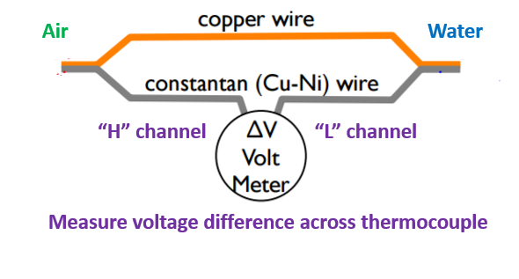
2. Keep E1 (brown thermocouple, thin tape around junction) and purple thermocouple J1 (“H” channel) in air at room temperature at all times. Be careful not to touch, move, or put anything near them that will change their temperature, since these are the controls.
3. You will take measurements for three different scenarios. For each temperature scenario, **carefully monitor the timing** of your measurements using the computer/station clock. Put both the **E2** (thick tape on brown TC) and **J2** (purple TC in “L” channel) in:
   1. Cold water from cooler. This is the **decreasing step input** of the dynamic performance portion of the lab. Be sure to **take note of the time**. They should be held very still, close together but not touching, and should not touch the cup. **Once the instruments have equilibrated,** measure the voltage difference in the purple circuit **for a total of 2 minutes.**
   2. Cold water from tap, shortly after removing E2 and J2 from the freezing water. You do not have to worry about dynamic response for this portion; this is for static calibration only. **Once the instruments have equilibrated,** measure the voltage difference in the purple circuit **for a total of 2 minutes**
   3. Hot water from tap, after letting E2 and J2 return to room temperature from the cold tap water (you can encourage them by holding your hands around them). This is the **increasing step input** of the dynamic performance portion of the lab. Be sure to **take note of the time**. They should be held very still, close together but not touching, and should not touch the cup. **Once the instruments have equilibrated,** measure the voltage difference in the purple circuit **for a total of 2 minutes**
4. **Once you have finished collecting your measurements**, save your data on the desktop by clicking “collect now”. Use the file convention **“Lab4_2024W_Group#and#”,** replacing # with your own group numbers.
5. Unwire the thermocouples from the datalogger and disconnect the battery.

**Assignment**

**Calculations for static calibration of Type E thermocouple**

1. In Excel or other software, **for each scenario**, calculate the temperature difference between the two temperatures measured by your reference instruments (E1 and E2).
2. Plot the transfer equation for your data (temperature difference between E1/E2 vs. voltage difference from J1/J2). /2
3. Draw a line of best fit to your data (you can do this manually or using your software). /1
4. What are the coefficient values and what do these represent?

How do they compare against the NIST standards found at http://srdata.nist.gov/its90/download/type_e.tab (table below)? Feel free to plot this data with your measured data, but be sure to label each dataset if you do. /2

ITS-90 Table for type E thermocouple

°C 0 1 2 3 4 5 6 7 8 9 10

Thermoelectric Voltage in mV

0 0.000 0.059 0.118 0.176 0.235 0.294 0.354 0.413 0.472 0.532 0.591

10 0.591 0.651 0.711 0.770 0.830 0.890 0.950 1.010 1.071 1.131 1.192

20 1.192 1.252 1.313 1.373 1.434 1.495 1.556 1.617 1.678 1.740 1.801

30 1.801 1.862 1.924 1.986 2.047 2.109 2.171 2.233 2.295 2.357 2.420

40 2.420 2.482 2.545 2.607 2.670 2.733 2.795 2.858 2.921 2.984 3.048

50 3.048 3.111 3.174 3.238 3.301 3.365 3.429 3.492 3.556 3.620 3.685

60 3.685 3.749 3.813 3.877 3.942 4.006 4.071 4.136 4.200 4.265 4.330

70 4.330 4.395 4.460 4.526 4.591 4.656 4.722 4.788 4.853 4.919 4.985

80 4.985 5.051 5.117 5.183 5.249 5.315 5.382 5.448 5.514 5.581 5.648

90 5.648 5.714 5.781 5.848 5.915 5.982 6.049 6.117 6.184 6.251 6.319

100 6.319 6.386 6.454 6.522 6.590 6.658 6.725 6.794 6.862 6.930 6.998

1. Write down your calibration equation. What temperature range is this equation valid for and why? (Assume that this was a “real” calibration.) /2
2. As mentioned, the calibration performed here is not perfect. What assumptions have been made, e.g. about the reference instruments/known quantities? Other assumptions? What would you change to make it a “real” calibration? /2

**Calculations for dynamic performance of the thermocouples**

1. Plot both temperature traces from your thermocouples (E2, and the temperature values calculated from the calibration equation for J2) on **one graph**, indicating the areas on the graph that represent the dynamic response **to each step input** (decreasing from room temperature to the icy water temperature, and increasing from room temperature to the hot water temperature). /2
2. Estimate the time constant, τ, for each sensor (be careful with your units!):
   1. By eye using the graph. /4
   2. Experimentally, using the method described in section (2.2.1) in the textbook /4

Marks will be awarded for explaining your method/showing your working in each case.

1. Your time constant for each thermocouple should be different. Which term(s) in the sensor time constant are different for your two sensors? /2
2. List the assumptions we are making when determining τ. If you got different answers for the step increase and decrease (for the same sensor), why do you think this is? /4
3. In previous labs, we have recorded data at a maximum frequency of 1 second. Why did we record at a higher frequency for this lab? /1

**Further lab questions (based on lectures and readings)**

1. A temperature sensor is subjected to a step input from *To* to *T∞.* After *t1* seconds, the temperature is shown to be *T1*. Find the time constant. /3
2. The sinusoidal input to a temperature sensor with a time constant τ is 3sin(2t) + 5sin(7t). What is the steady-state output? Show your work and state your assumptions. /4
3. Could the dynamic error of a first-order system with a sinusoidal input approach zero? If so, when? /1
4. The input to a first-order system is *at* (*a* = constant), with a steady-state output of *xs(t) = at – aτ*. Dynamic error is defined as the output minus the input at a given time, while dynamic lag is the time interval that passes before the output is equal to the input. Define:
   1. Dynamic error in terms of τ. /1
   2. Dynamic lag in terms of τ. /1
5. A certain sensor is designed to measure pressure between 700 and 1100 hPa. After fitting a straight-line equation, the transfer coefficients are *ao* = -7.00 V and *a1* = 0.0100 V hPa-1. Average and standard deviation of the residual errors are 0.00 hPa and 0.25 hPa respectively. Evaluate /6:
   1. The bias
   2. The imprecision
   3. The inaccuracy
   4. The span
   5. The static sensitivity
   6. When the output is 3.000 V, what is the input?
6. Indicate the number of significant digits in the following /4:
   1. 3.42 + 273.15
   2. 9.00 X 102
   3. 1013.25 hPa – 1012.5 hPa
   4. 1.2 X 97.12