**UBC ATSC 303 2024/25W**

**Lab 1 – Circuits (/85)**

**Teaching assistant: Andrew Barnett (He/Him/His)**

**E-mail:** [**abarn275@student.ubc.ca**](mailto:abarn275@student.ubc.ca)

**Quick resources:**

* Circuits : <https://www.allaboutcircuits.com/textbook/direct-current/chpt-5/building-simple-resistor-circuits/>
* Breadboards: <https://www.youtube.com/watch?v=6WReFkfrUIk>
* Multimeters: <https://www.youtube.com/watch?v=ts0EVc9vXcs>

**Learning goals**

1. Lab Safety and procedures
2. How to handle equipment (check-out and check-in)
3. Learn to build simple circuits (series, parallel, and bridge)
4. Learn to use a multimeter
5. Learn how to apply Ohm's and Kirchhoff’s Laws to (series, parallel, and bridge) circuits.

**Background**

Circuits Review

Brock Appendix D and Harrison Ch 3.

**Safety**

* A general overview of the lab (know where the fire extinguisher is located)
* There is a low risk of electric shock when handling the ELEGOO Resistor Wires and Breadboards. The most important rule is to not stick any foreign objects into the breadboard... ONLY the material provided.
* Have spatial awareness of the equipment you are working with; it can cause harm to others (e.g., don’t poke other students with the multimeter prongs).

Due to limited equipment, we will be working in groups.

**Experiment**:

Equipment needed:

(**Your group needs to check-out and check-in  everything listed below**)

* Breadboard
* 9V Battery
* Three 1 kΩ Resistors
* One 470 Ω Resistor
* One 2.2 kΩ Resistor
* Two resistors with unknown resistance (covered in colored electrical tape, please do not remove the tape or you ruin the fun of the lab)
* Three jumpers (small connecting wires – NOTE: you’ll only need two, but one is provided as a backup)
* Multimeter
  + Make sure to set the dial to the correct setting BEFORE it encounters any wires.
  + To measure voltage, set the dial to “V” (you may need to press SEL on the orange multimeter to change to DC). **The multimeter prongs should be in parallel** to the portion of the circuit you are trying to measure.
  + To measure current, set the dial to “mA” (you may need to press SEL on the orange multimeter to change to DC). The multimeter prongs must be in serial to the portion of the circuit you are trying to measure. **Hence, the multimeter should form part of the circuit**; you will need to break the circuit to ensure that the prongs complete it.
    - **DO NOT MEASURE THE CURRENT OF A CIRCUIT WITHOUT RESISTORS** (i.e., do not, accidentally, or otherwise, measure the current across the terminals of the battery). You will fry the multimeter or cause the battery to heat up dangerously.
  + To measure the resistance of a resistor, set the dial to the setting with the Ω symbol. The resistor must be disconnected from the circuit, and the multimeter prongs must be in contact with both legs of the resistor.

**Methods/Experiment**

**Part 0 – Battery Voltage**

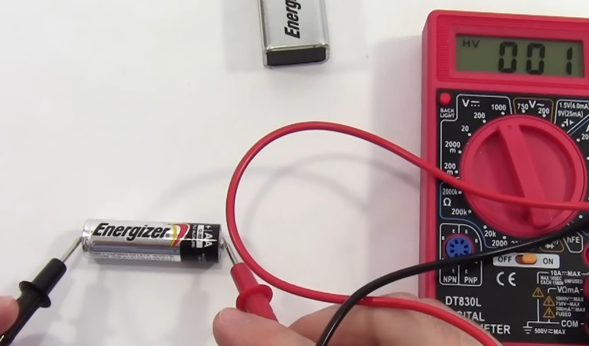

1. Measure and record the **voltage** of the battery. Make sure the multimeter is set to the “V” setting and ensure that you are reading DC. **(/1)**
2. Flip the prongs and measure and record them again. What do you see from the multimeter reading? Why is that the case? **(/2)**

**Part 1 - Simple Circuit (check QUICK REFERENCES at the end for more guidance)**

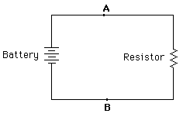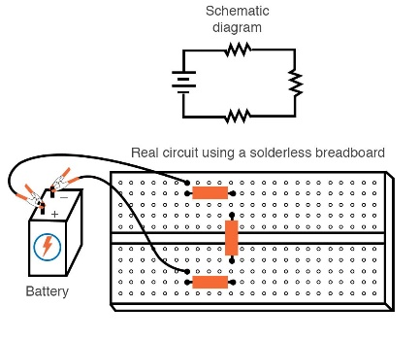*All about circuits*

1. Connect the battery in series with a 1kΩ resistor. Use the chart at the bottom of this lab to determine which resistor is 1kΩ. (Note that all resistors should have a tolerance of 1%, and therefore the fifth band must be brown). Confirm that you chose the right resistor by measuring its resistance with the multimeter (set the dial to the Ω setting first).
2. Next, change the multimeter to voltage (V) setting.
   1. Measure and record the voltage across the resistor. Ensure that you receive a positive reading by having the positive prong (red) at A, and the negative prong (black) at B. **(/1)**
   2. Does this differ from the voltage of the battery? Why or why not? **(/2)**
3. Calculate the current based on Ohm’s Law: **(/1)**
 $$V = I * R$$

  1. Measure the current on both sides of the resistor. Make sure the multimeter setting is first set to “mA”, and you are reading DC. You will need to break the circuit you created and complete it with the prongs of your multimeter. **(/1)**
   2. How does the current compare on both sides of the resistor? What law does your finding satisfy? **(/2)**
   3. How close was your calculation compared to what was measured? What might be some sources of error that could have caused this discrepancy? **(/2)**

**Part 2 - Voltage Divider (check QUICK REFERENCES at the end for more guidance)**

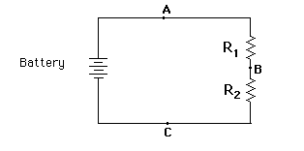*All about circuits*

1. Connect two known resistors in series (as shown in the figure above). Get practice reading the colour bands on the resistor. If you are unsure of the resistances, verify with the multimeter.
   1. R1 = 470 Ω
   2. R2 = 1 kΩ
2. First, change the multimeter to voltage (V) setting.
   1. Measure and record the voltages VAB  (i.e. across R1 , between points A and B), VBC (i.e. across R2, between points B and C), and VAC  (i.e. across both resistors, between points A and C). **(/3)**
   2. How does VAC relate to VAB and VBC? **(/1)**
   3. How does VAC compare with the voltage across the single resistor in Part 1? **(/1)**
3. Calculate the current based on Ohm’s Law across R1, R2, and across both resistors, using the voltages you measured earlier. **(/3)**
4. First, change the multimeter to current (mA) setting.
   1. Measure the current at A (remember to break the circuit first!). **(/1)**
   2. How close were your calculations compared to what was measured? What might be some sources of error that could have caused this discrepancy? **(/2)**
5. Disconnect the known resistor R2 and replace with the (**Black**) unknown resistor
   1. Again, measure and record the voltages VAB, VBC, and VAC. **(/3)**
   2. Compute the resistance ( Ω ) of the unknown resistor. **(/2)**
   3. Change the multimeter setting to measure the resistance of the unknown resistor using the multimeter (set the dial to the “Ω” symbol). **(/1)**
   4. Remove the tape of the unknown resistor and determine the manufactured resistance and tolerance from the chart at the end of the lab. State clearly how you determined your answer. **(/2)**
   5. How does your calculated resistance compare to the observed resistance and the manufactured specifications? Why do you see discrepancies between the resistances? **(/3)**

**Part 3 - Circuit in Parallel (check QUICK REFERENCES at the end for more guidance)**

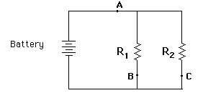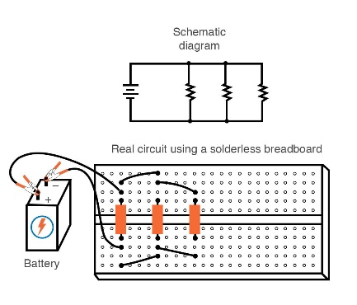 *All about circuits*

1. Connect two known resistors in parallel (as shown in the figure above)
   1. R1 = 2.2 kΩ
   2. R2 = 1 kΩ
2. Set the multimeter to measure and record the voltages VAB, and VAC. **(/2)**
3. Calculate the current based on Ohm’s Law at locations A, B, and C. **(/3)**
   1. Measure the current (current = break circuit 1st) at locations A, B, and C. **(/3)**
   2. How does the current at A relate to the currents at B and C? **(/1)**
   3. What do you notice about the ratio of currents at B and C, and the ratio of the resistances? **(/1)**
4. Suppose R1 and R2 were connected in series instead. What would be the total resistance of the circuit, and how does this compare to the total resistance of the parallel circuit above? **(/3)**

**Part 4 - Bridge Circuit (check QUICK REFERENCES at the end for more guidance)**

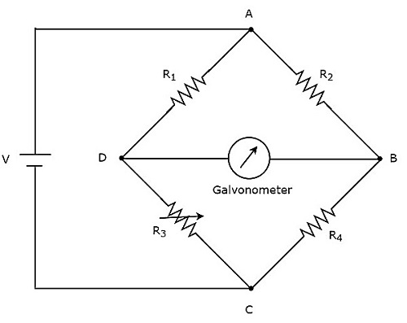

1. Connect three known and one unknown resistor (**Green**) in a bridge circuit (as shown in the figure above). Make sure the positive lead of the battery is connected to R1 and R2 (i.e., at junction A).
   1. R1 = 1 kΩ
   2. R2 = 1 kΩ
   3. R3 = Unknown Ω
   4. R4 = 1 kΩ
2. Calculate the resistance of R3 by setting the multimeter to measure the voltage VDB with the positive lead (red) of multimeter at junction D.
   1. What voltage did you measure? **(/1)**
   2. What is the calculated resistance of the unknown R3? **(/3)**
3. Calculate the resistance of R3 by measuring the voltages VAD and VAC with the positive lead (red) of voltmeter at junction A.
   1. What voltages did you measure? **(/2)**
   2. What is the calculated resistance of the unknown R3? **(/2)**
   3. Unwrap the tape from the **Green** resistors and determine its resistance from the color bands. **(/1)**
   4. How does this compare with what you calculated in the previous question? **(/2)**

**\*\*\*\*** **END OF MEASUREMENTS \*\*\*\***

**Concept Questions (based on lab/lecture/demo and readings)**

1. If you double the resistance of R2 and R4 in the bridge circuit in Part 4, what would be the new voltage drop across VDB ? **(/2)**
2. Suppose the resistance R3 you computed in Question 2 of Part 4 increased by 0.01 % because of a change in temperature. Assuming all other resistors are the same, what is the new value of VDB  ? **(/3)**
3. What is the new voltage drop across resistor R1, VAD? **(/2)**
4. Based on your answers to questions 2 and 3, why do we use bridge circuits in the field of atmospheric science? **(/3)**
5. Suppose R2 in the bridge circuit was removed, i.e., junctions A and B are disconnected. Assuming the temperature is back to what it was (i.e., using the resistance R3 you computed in Part 4), what are the new voltages and currents:
   1. Across R1? **(/2)**
   2. Across R3? **(/2)**
   3. Across R4? **(/2)**
6. For a circuit with a capacitor of unknown capacitance *C* and a resistor with known resistance 1 kΩ, compute the capacitance if the e-folding time is:
   1. 0.2 s **(/2)**
   2. 0.4 s **(/2)**
7. For a circuit with a capacitor of unknown capacitance *C* and a resistor with known resistance 470 Ω, estimate the capacitance given the following voltage data. Show how you obtained your answer --- see table on the next page. **(/5)**

|  |  |
| --- | --- |
| t (s) | Voltage (V) |
| 0 | 0.00 |
| 0.5 | 3.47 |
| 1.0 | 5.73 |
| 1.5 | 7.21 |
| 2.0 | 8.18 |
| 2.5 | 8.81 |
| 3.0 | 9.22 |
| 3.5 | 9.49 |
| 4.0 | 9.67 |
| 4.5 | 9.78 |
| 5.0 | 9.86 |
| 5.5 | 9.91 |
| 6.0 | 9.94 |
| 6.5 | 9.96 |
| 7.0 | 9.97 |
| 7.5 | 9.98 |
| 8.0 | 9.99 |
| 8.5 | 9.99 |
| 9.0 | 10.00 |
| 9.5 | 10.00 |
| 10.0 | 10.00 |

1. What might be some sources of error in trying to estimate the capacitance with the table above? **(/3)**

**QUICK REFERENCES:**

Good ways to measure the **Voltage** of a simple circuit

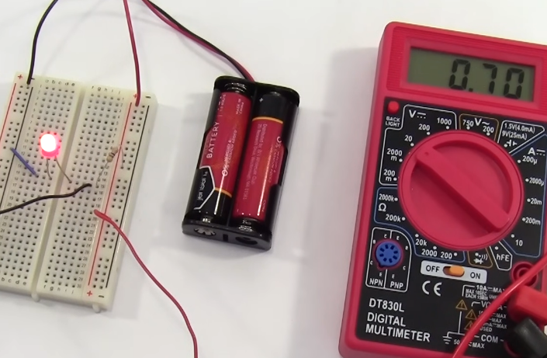

Good ways to measure the **Current** of a simple circuit

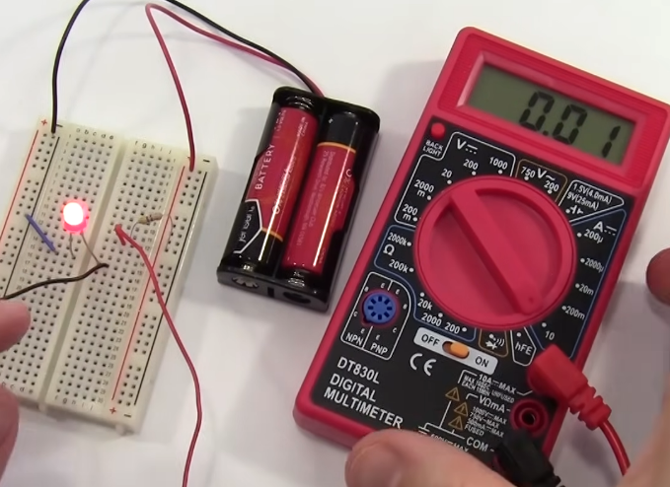

Good ways to measure the **Resistance** of a simple resistor

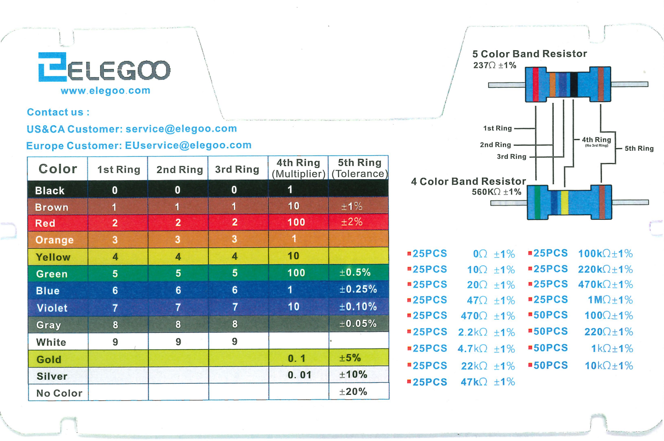

Circuit of a Wheatstone Bridge

<https://www.youtube.com/watch?v=qZocxkKGkKo>