**UBC ATSC 303 2024/25W**

**Lab 3 – Dataloggers, sampling, and analog-to digital conversion (/74)**

**Teaching assistant: Andrew Barnett (He/Him/His)**

**E-mail:** [**abarn275@student.ubc.ca**](mailto:abarn275@student.ubc.ca)

**Quick resources:**

* Playlist “Fundamentals of CRBasic Programming”: [Click here (YouTube link)](https://www.youtube.com/playlist?list=PLR_Ted9kITyJaTb0TtD_Cab9d9-sdryKf)
* CR1000x Datalogger (Part 1 of 4, make sure to watch all), Getting started: [Click here (YouTube link)](https://www.youtube.com/playlist?list=PLR_Ted9kITyJpTaFl3j3MtMXzk8Fg_BtH)
* How Infrared Thermometers Work: [Click here (YouTube link)](https://www.youtube.com/watch?v=Fy0pHGcgShs)

**Learning goals**

By the end of this lab, you should be able to:

1. Be confident in your handling of the physical sensors and software covered in this lab.
2. Wire an infrared thermometer to a datalogger.
3. Correctly program a datalogger to sample and average data from a sensor.
4. Reinforce the learning goals from the lecture and demo.

**Background**

Data Acquisition lecture and demo

Harrison: Ch. 4

LoggerNet Software Manual section 7.4

IRR-P Infrared Thermometer Manual section 4

**Safety**

* There is a shock risk if you touch the exposed end of datalogger power supply.

Due to limited equipment availability, we will be working in groups. All groups will work together to first write their code as a plain text file and then will test their code using the datalogger on a first come, first served basis.

**Method**

**Part 0 – Powering the Datalogger and Connecting it to the Computer**

Equipment:

* CR1000 datalogger
* PC laptop with LoggerNet software
* 12V battery power supply
* Power adapter
* Serial cable
* Small screwdriver

1. With both the extension breaker and the Battery power output OFF, connect the Battery Charger to a power outlet. If you are connecting it directly to an outlet without the use of an extension, do Step 2 first.
2. Using a small screwdriver, connect the Battery Charger to the 12 V Battery. Turn the extension braker ON.
3. Connect the Power Adapter to the 12 V Battery. **Red** wire to the 12 V port, **Black** wire to the Ground port.
4. With the laptop ON, connect the RS232 cable to the Datalogger in the correct port, and then to the computer (for Durabooks the RS232 port is at the back).
5. With everything connected, make sure to turn the Battery power output ON.
6. Open the LoggerNet software and proceed to connect the computer to the Datalogger. Make sure you upload the correct program. Your final setup should be similar to this:

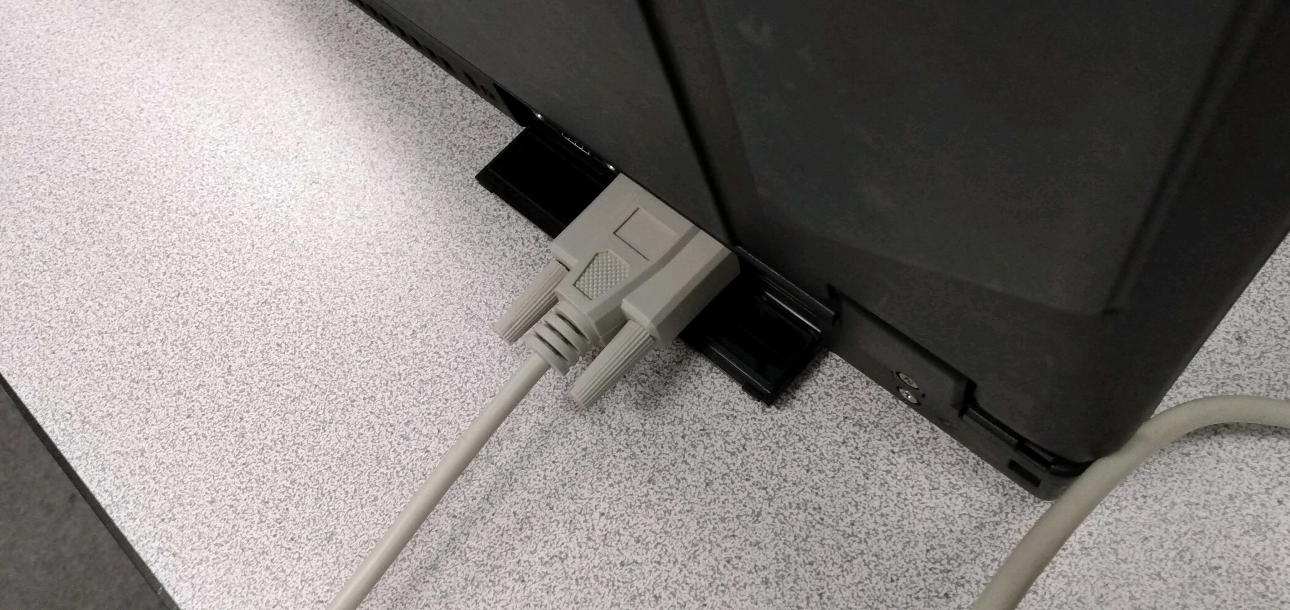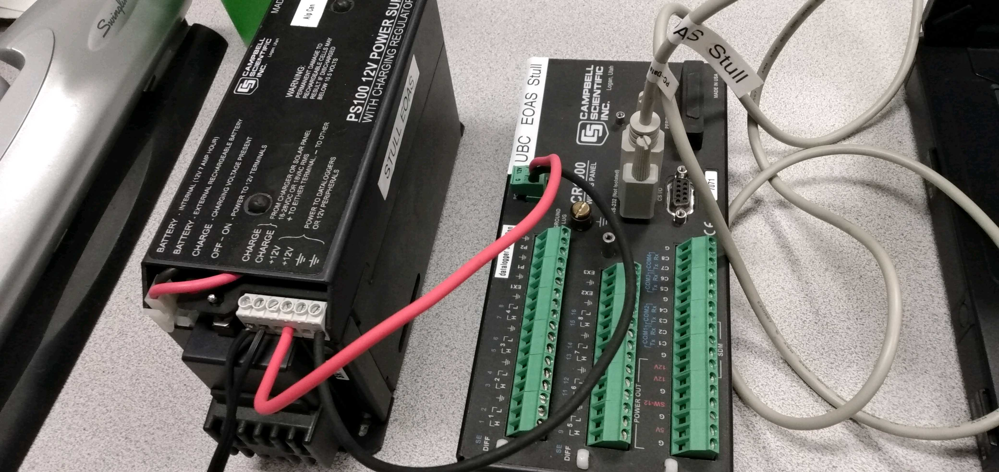

**Part 1 – Wiring the Infrared Thermometer to the datalogger**

Equipment:

* CR1000 datalogger
* PC laptop with LoggerNet software
* 12V battery power supply
* Power adapter
* Serial cable
* Small screwdriver
* IRR-P infrared thermometer

1. Wire your infrared thermometer to the CR1000 datalogger according to the schematic and table below.



Note: Analog Ground is the “Inverted Tree” Symbol

|  |  |  |  |
| --- | --- | --- | --- |
| Generic Table 5-1 from IR Thermometer Manual | | | |
| **Sensor/Lead** | **Description** | **CR10X** | **CR1000** |
| **IRR-P Thermopile** | Target Temp |  |  |
| Red | Diff. High | H | H |
| Black | Diff. Low | L | L |
| Clear | Analog Ground | AG | Ground |
| **IRR-P Thermistor** | Sensor Temp |  |  |
| Green | SE | SE | SE |
| Blue | Analog Ground | AG | Ground |
| White | Excitation | E | EX/VX |

**Part 2 – Programming the datalogger (~30 min.; groups of 4/5)**

1. Download the provide code template from Canvas (link)
2. The two functions you’ll need to use in the main part of the program are VoltDiff() and Therm109(). The mandatory parameters for these functions are:

*Repetitions=1, RevDiff=True, SettlingTime=0, Integration=_60Hz, Multiplier=1, Offset=0*

1. Below are the equations for bias removal due to sensor’s own body temperature:

$$T=\sqrt[4]{s^{4}+mv+b}-273.15$$

$$m=mC2*s_{c}^{2}+mC1*s_{c}+mC0$$

$$b=bC2*s_{c}^{2}+bC1*s_{c}+bC0$$

s = sc + 273.15, sensor body temperature in Kelvin

sc = result of Therm109(), sensor body temperature in degrees Celsius

v = result of VoltDiff()

T = target temperature in degrees Celsius

mC# and bC# constants are specific to each IR sensor and are provided by Campbell Scientific:

|  |  |  |  |
| --- | --- | --- | --- |
| **IR Sensor** | **Short Cord**  **s/n 1242** | **White Cord End**  **s/n 1243** | **Long black cord**  **s/n 2014** |
| mC2 | 16433.1 | 45575.1 | 82603 |
| mC1 | 11153600 | 10424800 | 9307700 |
| mC0 | 1471420000 | 1502160000 | 1543600000 |
| bC2 | 70373.1 | 48198.2 | 30256 |
| bC1 | -2577420 | -2286640 | -454070 |
| bC0 | -3878910 | 447583 | -19079000 |

***Be sure your code is easily editable for any of the above sensors***

1. Your code must be able to output EXACTLY the following in a data table:
   1. **Sample** and **average** target temperature every **10 seconds**. (degC) /2
   2. **Average** IR sensor body temperature every **10 seconds**. (degC) /1
   3. Sample the **minimum** battery voltage every **10 seconds**. (V) /1

In addition, your actual code must meet the following requirements.

* 1. Compiles successfully. /1
  2. Well-documented (be liberal with your comments; names and date at the top of the code, with an explanation of what your code is trying to do). /2
  3. Does what it is supposed to do, and nothing more. **No extraneous code** (there should not be any lines related to humidity or barometric pressure, for example). /1

1. Once you think you are ready to test your code, Save your template with the following naming convention: **lab3_2024W_Group#.txt.** After, send your code by email to your TA with your group number in the subject line.
2. Open LoggerNet and find the CRBasic Editor. You will see a code template. Open the text you sent to your TA, copy and paste the code in the text file into the CRBasic editor.
3. You will be given one of the IR thermometers. Make adjustments (ie. Comment out) to your code to ensure you have the correct constants for your sensor. Once you have made the proper adjustments, save your code with the following naming convention to the **Desktop**: **lab3_2024W_Group#.CR1.**
4. Once your code has compiled successfully, test it by sending your file to the datalogger, and try collecting some temperature data to make sure that your data table is displaying the right values (e.g., your hand, your computer, a cold window/surface).
5. Show your output/data table to the TA. Save your data table to the **Desktop** with the following naming convention: **lab3_2024W_Group#.dat**

**Questions (based on lab/lecture/demo/readings)**

**1.** Why should you always record the battery voltage? /2

**2.** Why is it a good idea to record sampled and averaged data? /2

**3.** What is the minimum sampling frequency you need if you want to measure a diurnal temperature cycle? What would be an ideal frequency? /2

**4.** On a CR1000 what is the maximum approximate timespan you can record for before the datalogger runs out of memory, if we take 1 measurement:

a. per second /.5

b. per minute /.5

c. per hour /.5

d. per day /.5

e. What can you do to avoid running out of memory? /2

f. For a-d, what meteorological variables would you want to measure? /2

*Hint: see the CR1000 specs, assume each recorded line of text (timestamp) is 30 Bytes.*

**5.** Give at least 1 example of a meteorological “datalogger” that existed before the invention of computers. /1

**6.** List three things that can harm a datalogger when it is deployed in the field. What can be done to prevent each? /2

**7.** Calculate the quantum size of the CR1000. What does this tell us? /4

**8.** Once digitized, your data may have errors. Some of these errors are irreversible. List 3 irreversible effects. How do you prevent each one? /3

**9.** Using the table below, which represents the real signal in nature (plot the Fourier spectrum if it helps), what is the Nyquist frequency and resulting apparent data (i.e.: fill in a table or show/plot values on Fourier spectrum), if your sampling interval is /6:

a. 1.25s

b. 1s

c. 0.625s

|  |  |
| --- | --- |
| Frequency (Hz) | A2 (degC) |
| .1 | 2 |
| .2 | 1 |
| .3 | 0 |
| .4 | 0 |
| .5 | 3 |
| .6 | 4 |
| .7 | 2 |

**10.** Given the Campbell Scientific CR6 data logger specs for Analog Voltage measurement:

* Max sustained sampling frequency: 100 Hz
* Max voltage range: ± 5 V
* Analog-to-Digitial converter: 24 bits

1. What is the time resolution (i.e., the shortest time interval between digitized samples), given in ms? /1
2. What is the value of the Nyquist frequency (Hz)? /1
3. If your analog signal contained a natural frequency of 70 Hz, it would appear in your digitized data at _______ Hz . /1
4. If your analog signal contained a natural frequency of 40 Hz, it would appear in your digitized data at _______ Hz. /1
5. How many digitized voltage states are possible? /1
6. What is the amplitude resolution (i.e., the smallest voltage change that can be measured)? Answer in µV. /1

**11.** The output of a barometer has a range of 800 to 1100 hPa. At least how many binary bits does an ADC need to digitize the barometer to a desired resolution of 0.05 hPa? /2

**12.** An input signal has a frequency of 10 Hz, and is sampled 8 times every second. What will be the apparent output frequency? *Hint: frequency folding occurs around the Nyquist frequency and around zero.* /2

**13.** Indicate which of the following are analog and which are digital /3:

1. Temperature indicated by an LiG thermometer.
2. The temperature you write down on an observation sheet
3. The position of a pointer on an aneroid barometer dial
4. Output from an analog signal conditioning device
5. Output of a tipping bucket rain gauge
6. Output of a cup anemometer equipped with a light-chopping transducer.

**14.** If we record the output of a LiG thermometer as 296.3 K, is this a digital output? If so, where did the ADC conversion take place? /2

**15.** A circuit has a 9-V battery (ignore internal resistance) and three resistors in series: 100 Ω, 200 Ω, 300 Ω. /5

1. Find the equivalent resistance of the circuit.
2. Calculate the current passing through each resistor.
3. Find the total current through the battery.
4. Calculate the voltage across each resistor.
5. Find the power dissipated in each resistor.

**16.** Redo the last problem, but this time with the resistors in parallel. /5

**17.** Three equal resistors are connected in series. If you pass a voltage *V* through the circuit, the total power dissipated is 1 W. What power would be dissipated if the three resistors were instead connected in parallel, with the same voltage applied? /3

**18.** What is the maximum allowable voltage across a 10 kΩ resistor with a power rating of 1/4 W? /2

**19.** For a bridge circuit with four resistors (three of which have a resistance of *R3*)and a gain of *G* = 1, given a reference voltage *VR* and a voltage difference Δ*V*, find *RT*. What is *RT* if there is no voltage difference between the two voltage dividers? /3

**20.** Consider a capacitor, with *V* = 0 at an initial time *t* = 0.

1. What is the equation for the rate of change of voltage across this capacitor at any given time? /1
2. What is the initial rate of change? /1
3. What happens to this rate if you increase the capacitance? /1

**21.** A #22 wire has a 0.65 mm diameter and is made up of copper. What is its resistance per meter? How many meters would you need to make 1 $Ω$? /2