**UBC ATSC 303 2024/25W**

**Lab 6 – Hygrometry (/40)**

**Teaching assistant: Andrew Barnett (He/Him/His) | Kat Pexa (They/Them)**

**E-mail:** [**abarn275@student.ubc.ca**](mailto:abarn275@student.ubc.ca) **|** [**katrina.pexa@ubc.ca**](mailto:katrina.pexa@ubc.ca)

**Quick resources:**

* Playlist “Fundamentals of CRBasic Programming”: [Click here (YouTube link)](https://www.youtube.com/watch?v=yBQCHf9XNT0&list=PLR_Ted9kITyJaTb0TtD_Cab9d9-sdryKf)
* Relative Humidity vs. Dewpoint: [Click here (YouTube link)](https://www.youtube.com/watch?v=OiejHVHrdOo)
* Dry and Wet Bulb Hygrometer: [Click here (YouTube link)](https://www.youtube.com/watch?v=RwlgkAM4V6A)

**Learning Goals**

By the end of this demo/lab, you should be able to:

1. Be confident in your handling of the physical sensors and software covered in this lab.
2. List the sources of error and potential problems with each sensor.
3. Calculate and convert between different humidity variables.
4. Reinforce the learning goals from the lecture and demo.

**Background:**

Hygrometry lecture and demo

Harrison: Ch. 6

**Safety:**

**Please take care** while using the psychrometers. They are fragile and contain mercury and are borrowed!

**Method**

**Part 0 – Powering the Datalogger and Connecting it to the Computer**

Equipment:

* CR1000 datalogger
* PC laptop with LoggerNet software
* 12V battery power supply
* Power adapter
* Serial cable
* Small screwdriver

1. With both the extension breaker and the Battery power output OFF, connect the Battery Charger to a power outlet. If you are connecting it directly to an outlet without the use of an extension, do Step 2 first.
2. Using a small screwdriver, connect the Battery Charger to the 12 V Battery. Turn the extension braker ON.
3. Connect the Power Adapter to the 12 V Battery. **Red** wire to the 12 V port, **Black** wire to the Ground port.
4. With the laptop ON, connect the RS232 cable to the Datalogger in the correct port, and then to the computer (for Durabooks the RS232 port is at the back).
5. With everything connected, make sure to turn the Battery power output ON.
6. Open the LoggerNet software and proceed to connect the computer to the Datalogger. Make sure you upload the correct program. Your final setup should be similar to this:

**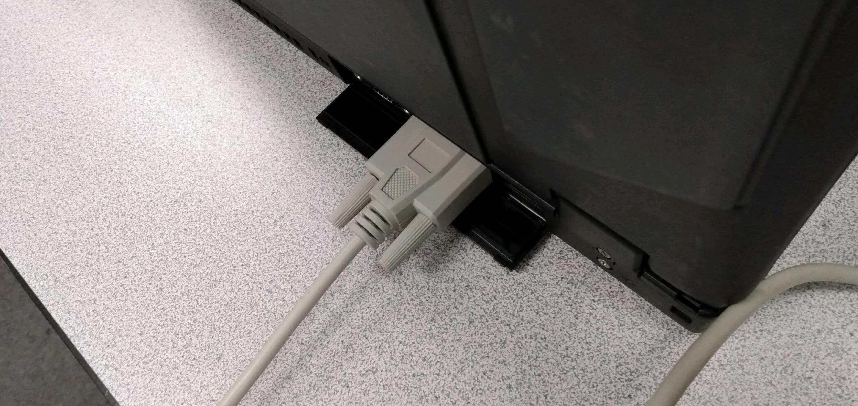  
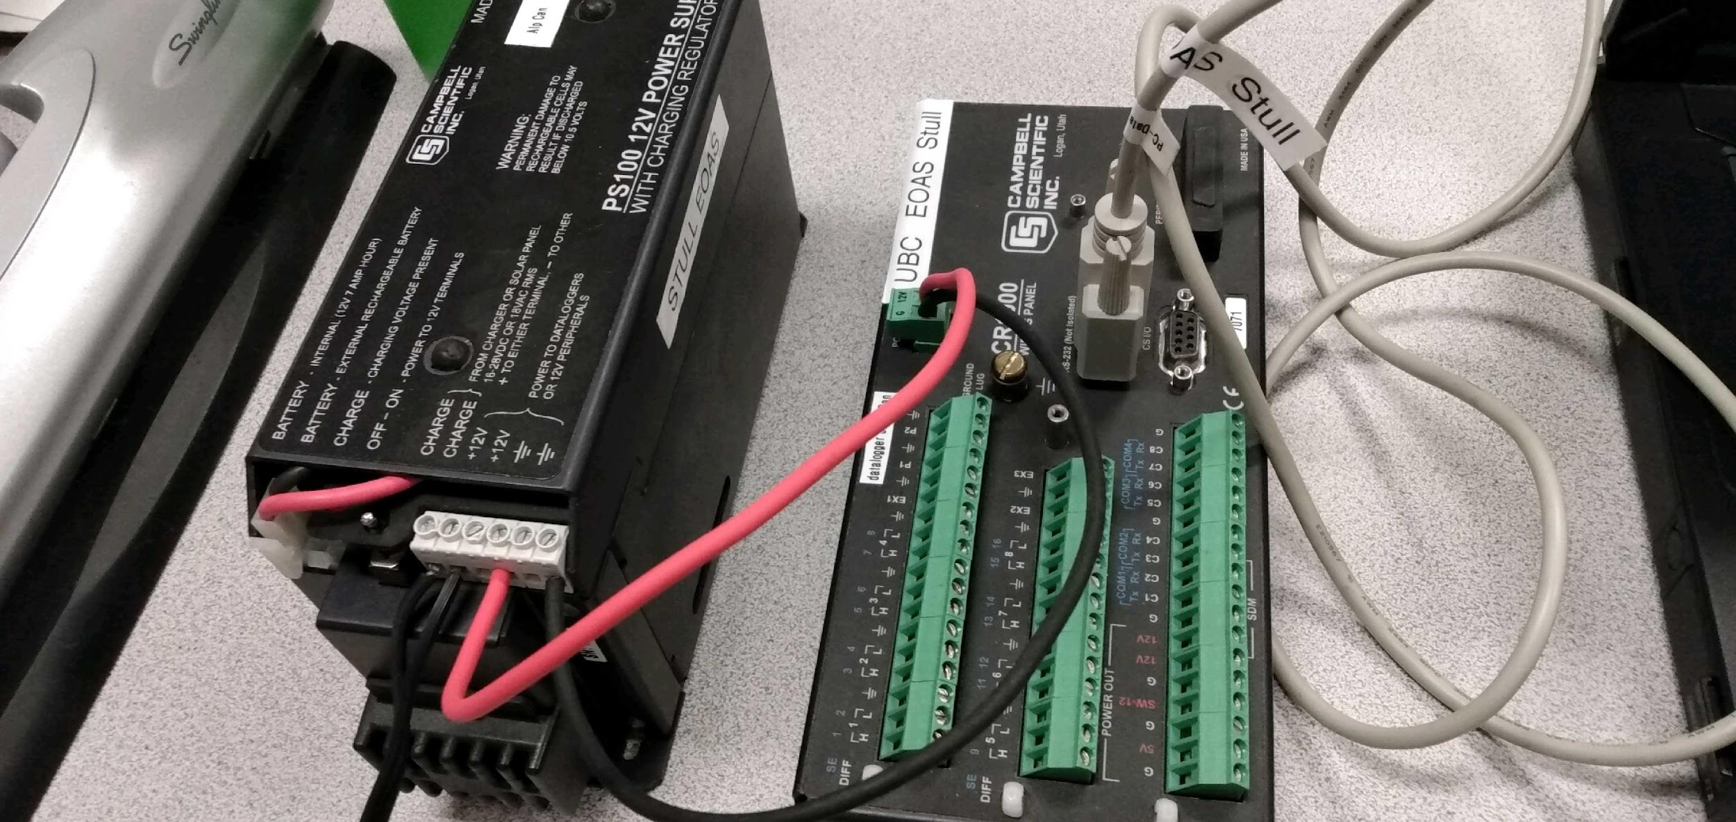**

**Part 1 – Measurements for comparison of hygrometers**

Equipment:

* CR1000 datalogger
* PC laptop with LoggerNet software
* 12V battery with power supply
* Power adapter
* Serial cable
* Small screwdriver
* Campbell Scientific HC-S3-XT relative humidity sensor **OR** MetOne 083D relative humidity sensor
* Assmann psychrometer
* Blue silica beads
* 2x Ziploc bags (for low/high humidity)
* Electrical tape for sealing hole around instrument

1. Wire your humidity sensor to the CR1000 datalogger (see appendix A for wiring details).
2. The datalogger program has already been written for you, check with the instructor/TA that the datalogger has the correct program on it. **Lab6CS.CR1** for the Campbell Scientific RH sensor or **Lab6MetOne.CR1** for the MetOne RH sensor **(both located on the Desktop)**. Check if the response of the instrument is correct. Breathe gently on it to see if the humidity and temperature increase.
3. You will be measuring **three** different humidity scenarios. For each scenario you will simultaneously measure the ambient air humidity using the Assmann Psychrometer approximately every minute. **(Remember to use distilled water on the wet bulb).** Note the start and end time for each scenario, use the datalogger’s time.
   1. **DRY** scenario: Add some silica beads to one Ziplok bag and insert your sensor, **taking note of the time**. You do not need a lot of silica. Tape around the hole so no outside air can get in or out. Once the reading has stabilized, take measurements for approximately **3 minutes**.
   2. **AMBIENT** scenario: remove your sensor and once equilibrated, take measurements in ambient air for approximately **3 minutes**.
   3. **HUMID** scenario: breathe into a **(new!)** Ziplok bag, inflating it with only your breath. Insert your sensor and seal the Ziplok tightly around it. Once in equilibrium, take measurements for approximately **3 minutes**. Note the time that you finish taking measurements.
4. Click “Collect Now” on the Connect screen. Name your file using the following naming convention: **Lab6_Group#.dat.** Do not disconnect the datalogger. The data will be posted to the website following the lab.

**Lab questions (based on lecture and readings)**

1. Plot all of your relative humidity measurements from the electronic sensor (Campbell Scientific or MetOne) on **one graph, as a time series**. Indicate the area(s) on the graph that represent each scenario. /4
2. Calculate and plot the vapour pressure, *e*, on a **separate time series graph** for the complete dataset. You should have the same number of data points as on your graph for question one. (You will first need to calculate the saturated vapour pressure, *es*, using the temperature data collected simultaneously.) Again, indicate the area(s) on the graph that represent each scenario. /4
3. Determine where the static portion of your data is for each scenario. Average this data --- should have **three** datapoints (3 temperatures and 3 corresponding relative humidities). Assume that the pressure P = 100 kPa. What is the mixing ratio, *r*, for each of the three scenarios? Make sure your units are consistent! /4
4. Write down the drybulb and wetbulb temperatures and wetbulb depression measurement from the Assmann psychrometer. Convert this measurement to relative humidity using a psychrometric graph (HINT: lecture notes page 18-19). How does this value compare with your **average** ambient relative humidity measurement from the Campbell Scientific/MetOne sensor? Which one represents the true relative humidity? /5
5. List sources of error for each sensor. /4
6. The data you recorded was sampled at a 1-second frequency. Do you think this is a reasonable sampling rate for measuring humidity with these sensors? If not, how would you sample/average the data, and why? /3
7. The addition of salt lowers the vapour pressure of water. Will the presence of salt on the wet bulb of a psychrometer cause the wet-bulb temperature to read too high or too low? /4
8. Why should air not flow from the wet bulb to the dry bulb? /1
9. A carbon hygristor is a plastic strip coated with a hygroscopic mixture containing a suspension of finely divided carbon particles. Its electrical resistance increases as the relative humidity increases. What physical mechanism causes this? /1
10. A certain humidity sensor produces the following output:

| Vapor pressure (Pa) | 1000 | 2000 | 3000 | 4000 |
| --- | --- | --- | --- | --- |
| Output *Y1* (V) | 2.500 | 2.596 | 2.685 | 2.786 |

1. What is the static sensitivity at the low end of the range (i.e., between a vapor pressure of 1000 and 2000 Pa)? /3
2. Is this sensor linear? Explain. /3
3. How does a chilled-mirror dewpoint hygrometer detect condensation on the mirror? /4

**Appendix A – Wiring details for Campbell Scientific and MetOne RH sensors**

**Wiring for Campbell Scientific temperature and humidity sensor:**

Temperature and RH

* Brown – Diff channel 1H
* Blue – Diff channel 1L
* White – Diff channel 2H
* Jumper to blue – Diff channel 2L
* Grey – Ground (power reference)
* Green – 5V power
* Clear – signal ground

**Wiring for MetOne temperature and humidity sensor:**

Relative humidity

* Black – SE channel 1
* Green – signal ground
* Red – 12V power

Temperature

* Black – SE channel 7
* White – signal ground

**Appendix B – Datalogger programs**

**Program for Campbell Scientific sensor:**

'CR1000 Series Datalogger

'Program to measure temperature and RH.

' Differential measurement using CS HC-S3-XT sensor.

'date: 11 February 2015

'program author: Rosie Howard

'Declare Public Variables and Units

Public Batt_Volt

Units Batt_Volt=Volts

Public PTemp

Units PTemp=degC

'Variables for CS sensor

Public T_CS

Public RH_CS

Units T_CS=degC

Units RH_CS=%

'Define Data Tables

DataTable (CS,True,-1) 'CS sensor, sampled every second

DataInterval (0,1,Sec,0)

Minimum (1,batt_volt,FP2,0,False)

Sample (1,T_CS,FP2)

Sample (1,RH_CS,FP2)

EndTable

'Main Program

BeginProg

Scan (1,Sec,0,0)

'Measure panel temperature of datalogger

PanelTemp (PTemp,250)

'Default Datalogger Battery Voltage measurement Batt_Volt:

Battery (Batt_volt)

'Generic Differential Voltage measurements T (CS):

VoltDiff(T_CS,1,mV2500,1,True,0,_60Hz,0.1,-50)

'**-50 for XT model

'Generic Differential Voltage measurements RH (CS):

VoltDiff(RH_CS,1,mV2500,2,True,0,_60Hz,0.1,0)

' Multiplier=0.1 to convert mV to percentage

'Call Data Tables and Store Data

CallTable(CS)

NextScan

EndProg

**Program for MetOne sensor:**

'CR1000 Series Datalogger

'Program to measure temperature and RH using MetOne sensor.

'date: 11 February 2015

'program author: Rosie Howard

'Declare Public Variables and Units

Public Batt_Volt

Units Batt_Volt=Volts

Public PTemp

Units PTemp=degC

'Declare variables for MetOne temperature probe

Public T_MO 'Temperature measured by MetOne probe

Public X 'Output ratio of measured voltage to excitation voltage

Public Rs ' Resistance calculated from ratio and further eqns

Units T_MO=degC

Units Rs=ohms

'Declare variables for MetOne humidity probe

Public RH_MO 'relative humidity measured by MetOne probe

Units RH_MO=%

'Define Data Tables

DataTable (MO,True,-1) 'MO sensor, sampled every second

DataInterval (0,1,Sec,0)

Minimum (1,batt_volt,FP2,0,False)

Sample (1,T_MO,FP2)

Sample (1,RH_MO,FP2)

Sample (1,Ptemp,FP2) ‘This was added due to faulty temperature sensor

EndTable

'Main Program

BeginProg

Scan (1,Sec,0,0)

'Instructions for MetOne temperature probe

'Half-bridge measurement for Air_Temp:

BrHalf (X,1,mV2500,7,Vx1,1,1000,True ,0,_60Hz,1.0,0)

' Convert output X into resistance

Rs = 23100*(X/(1-X))

' 23100 equals resistance of resistor in circuit

' Convert resistance output to temperature (degC)

T_MO = ((((1/Rs)+(1/23100))^-1)-13698.3)/(-129.163)

'Measure panel temperature of datalogger

PanelTemp (PTemp,250)

'Default Datalogger Battery Voltage measurement Batt_Volt:

Battery (Batt_volt)

'Generic Single-ended Voltage measurements RH:

VoltSE(RH_MO,1,mV2500,1,True,0,_60Hz,0.1,0)

' Multiplier=0.1 to convert mV to percentage

'Call Data Tables and Store Data

CallTable(MO)

NextScan

EndProg