**UBC ATSC 303 2024/25W**

**Lab 7 – Precipitation (/50)**

**Teaching assistant: Andrew Barnett (He/Him/His) | Kat Pexa (They/Them)**

**E-mail:** [**abarn275@student.ubc.ca**](mailto:abarn275@student.ubc.ca) **|** [**katrina.pexa@ubc.ca**](mailto:katrina.pexa@ubc.ca)

**Quick resources:**

* How a tipping bucket rain gauge works [Click here (YouTube link)](https://www.youtube.com/watch?v=ygLJV8upFQ4)
* Snow measurements – Recording gauges: [Click here (YouTube link)](https://www.youtube.com/watch?v=9_F9sy8jfVU)
* The Science of Snowflake: [Click here (YouTube link)](https://www.youtube.com/watch?v=fUot7XSX8uA)

**Learning Goals**

By the end of this lab, you should be able to:

1. Be confident in your handling of the physical sensors and software covered in this lab.
2. Perform calculations to critically analyze data from these sensors.
3. Discern which precipitation sensors are appropriate for which situations/applications.
4. Reinforce the learning goals from the lecture and demo.

**Background**

Harrison: Ch. 10

**Method**

**Part 0 – Measurements and calculations using a tipping bucket rain gauge.**

***Note the questions you need to answer in this section.***

Equipment:

* Tipping bucket rain gauge
* Measuring jug
* Container/water-catcher

1. Assume that each tipping cup holds 9 ml of water. If the cup tips 11 times in one hour, what is the rain rate? You will need to make a simple measurement to help you calculate your answer. Show all your work. (HINT: 1 ml = 1 cm3. Be careful with units.) **/4**
2. **Very slowly** pour 100 ml of water into the tipping bucket rain gauge. You should pour it against the inside wall of the funnel, so the water trickles through the drain and the bucket tips slowly. You can repeat the experiment if you don’t get this right the first time. Log the number of tips. Does this number differ from the number of tips in question 1? If so, why do you think this is the case? **/2**
3. Why is it a good idea to make tipping bucket rain gauges out of black materials? **/1**
4. List potential sources of error for tipping bucket rain gauges. **/4**

**Method**

**Part 1 – Powering the Datalogger and Connecting it to the Computer**

Equipment:

* CR1000 datalogger
* PC laptop with LoggerNet software
* 12V battery power supply
* Power adapter
* Serial cable
* Small screwdriver

1. With both the extension breaker and the Battery power output OFF, connect the Battery Charger to a power outlet. If you are connecting it directly to an outlet without the use of an extension, do Step 2 first.
2. Using a small screwdriver, connect the Battery Charger to the 12 V Battery. Turn the extension braker ON.
3. Connect the Power Adapter to the 12 V Battery. **Red** wire to the 12 V port, **Black** wire to the Ground port.
4. With the laptop ON, connect the RS232 cable to the Datalogger in the correct port, and then to the computer (for Durabooks the RS232 port is at the back).
5. With everything connected, make sure to turn the Battery power output ON.
6. Open the LoggerNet software and proceed to connect the computer to the Datalogger. Make sure you upload the correct program. Your final setup should be similar to this:

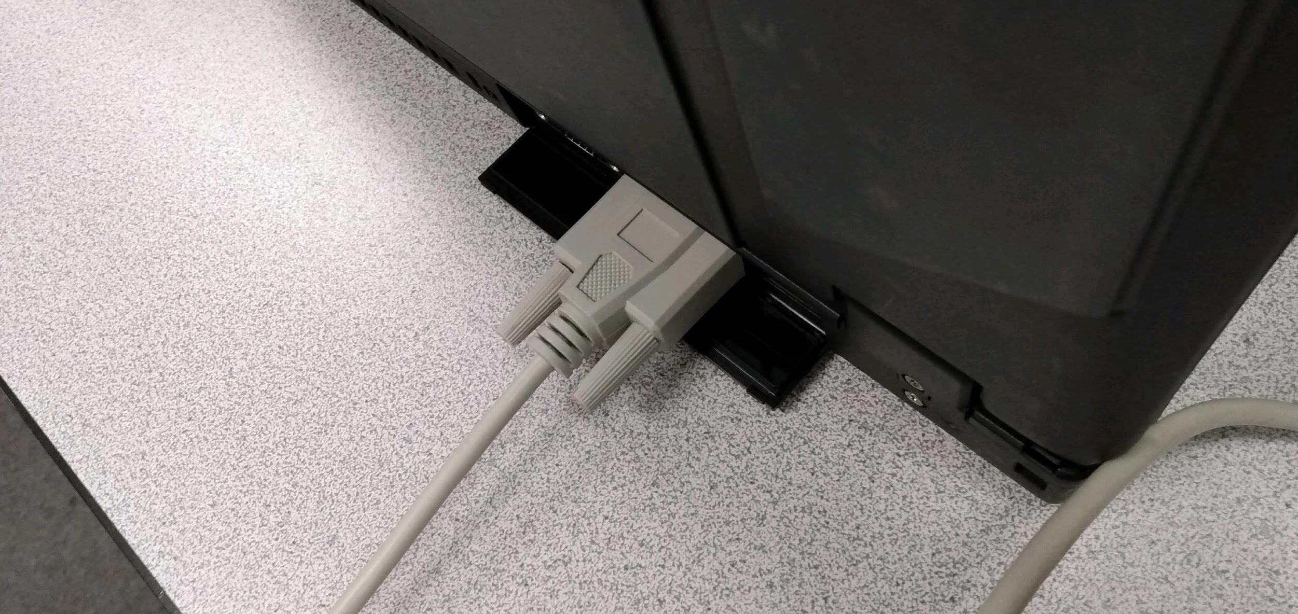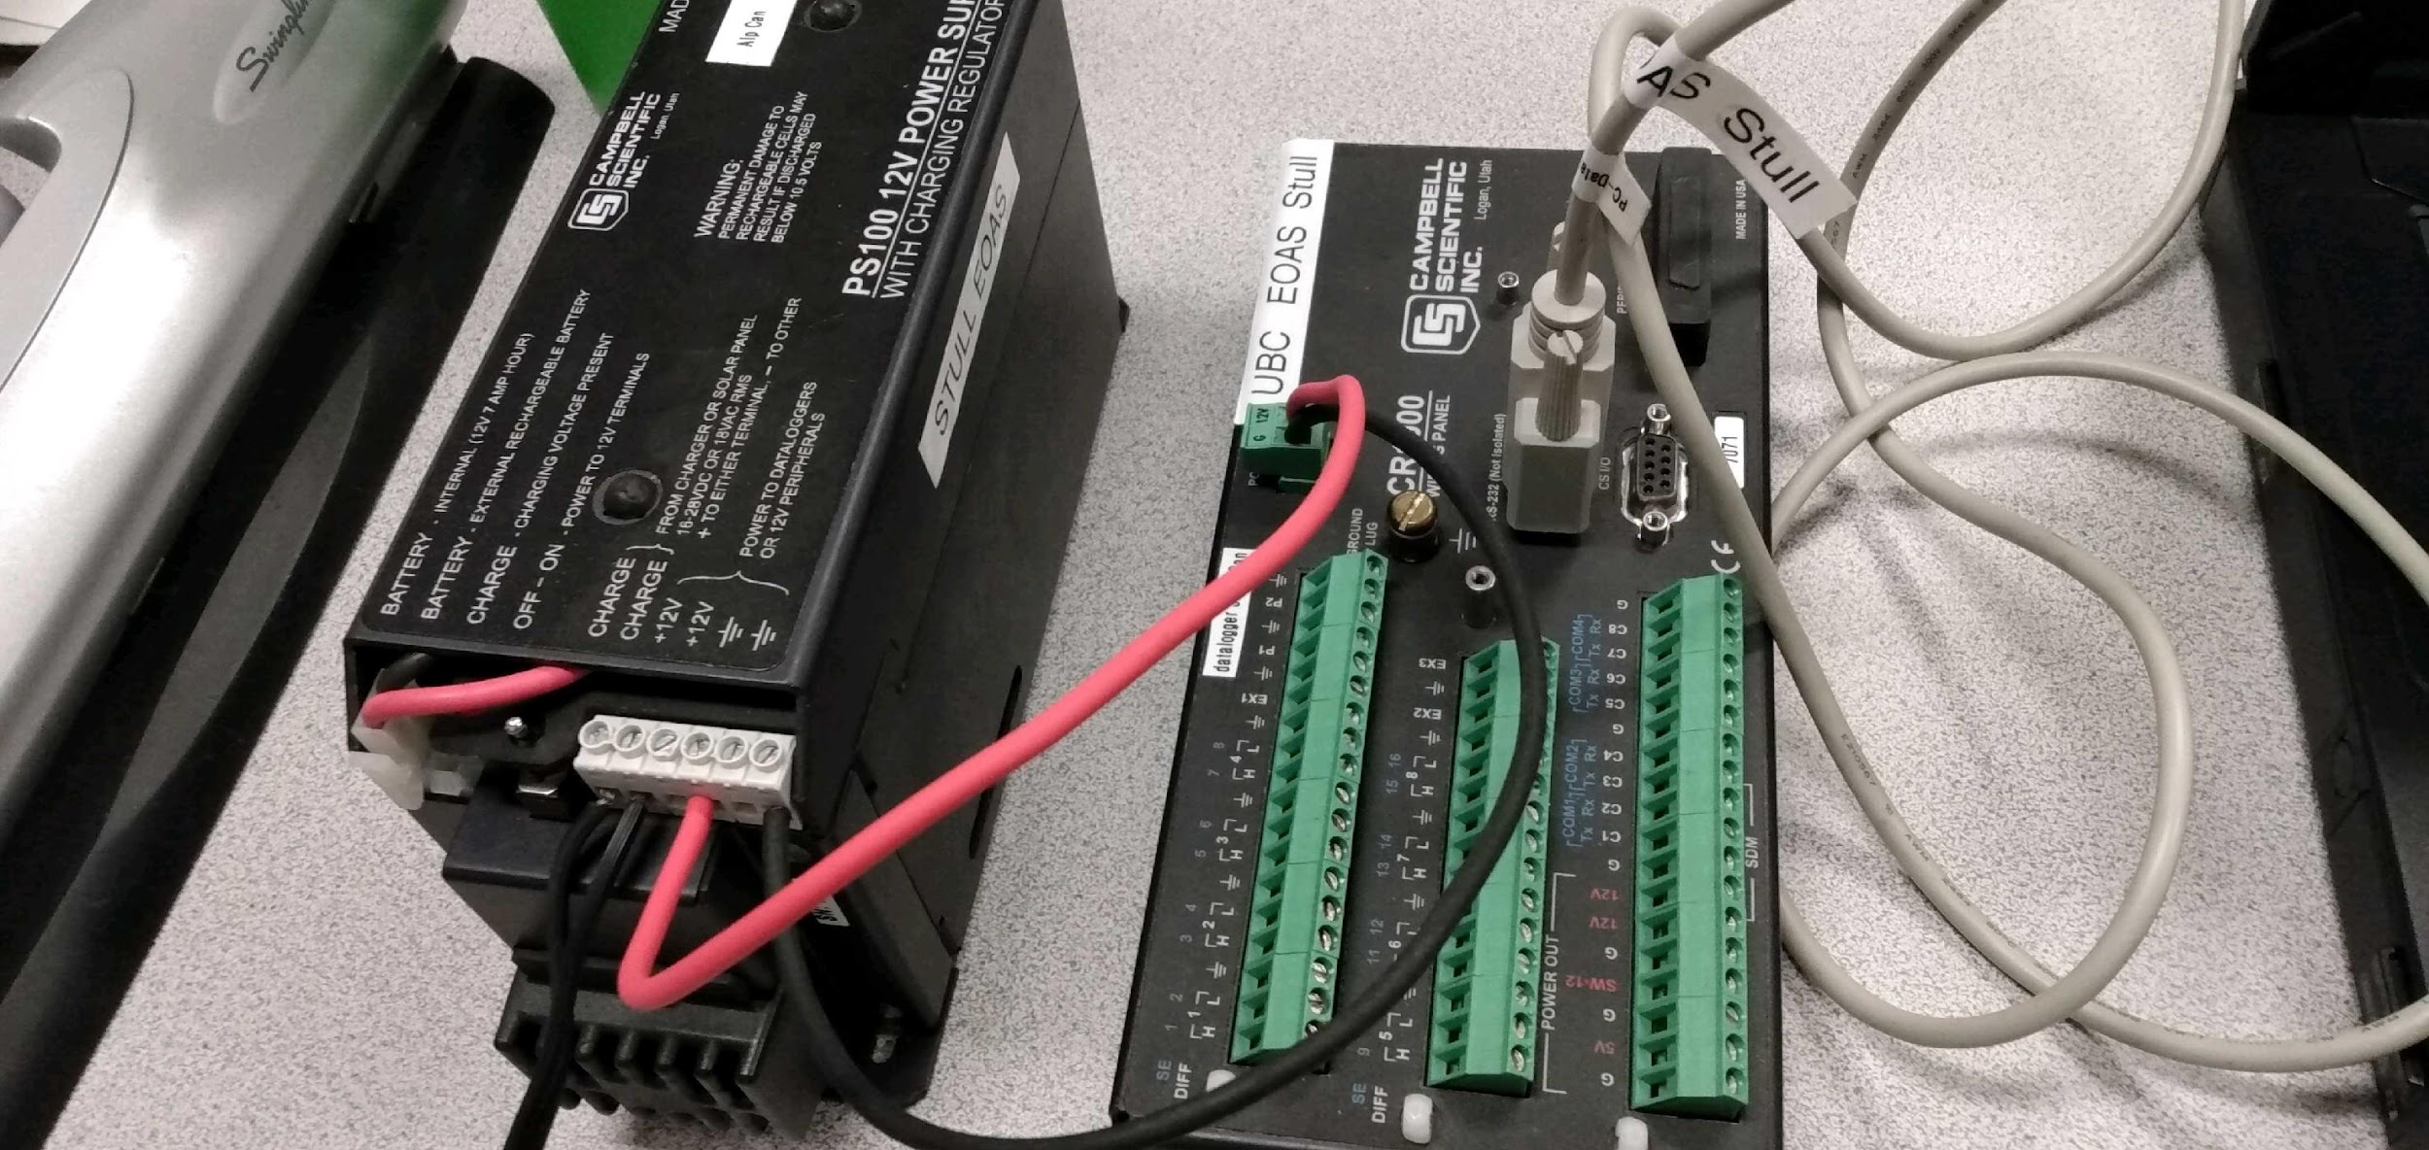

**Part 2 – Measurements using a sonic ranging sensor**

***Note the questions you need to answer in this section.***

Equipment:

* CR1000 datalogger
* PC laptop with LoggerNet software
* 12V battery power supply
* Power adapter
* Serial cable
* Small screwdriver
* Sonic ranging sensor (for snow depth)
* HC-S3-XT air temperature sensor
* Tape measure

1. Wire the sonic ranger and the temperature sensor to the datalogger using the wiring tables in appendix A. **The order in which the connections are made is critical. Do it in the order they are listed. When disconnecting the sensor, the reverse order should be followed.**
2. The datalogger program has been written for you. Connect to the datalogger and check that the instruments respond correctly. (TCDT = temperature-corrected distance to target (m).)
3. Record multiple distances, from very close to the instruments extending to far away, perpendicular to the wall, using: (1) the **tape measure**, and simultaneously for comparison (2) the **sonic ranging** sensor (TCDT from the Numeric table). Also note the **air temperature** for the same times. (Recall that you can take multiple measurements for the same distance and instrument if you want to increase your precision.)
4. The sonic ranging sensor has a field of view of approximately 22° (solid angle, see the figure on the next page).

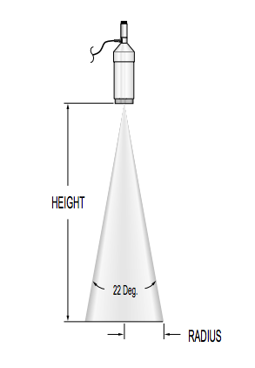

**Cone angle of the sonic ranging sensor.**

**Plot the distance measured by your tape measure vs. that measured by the sonic ranger on a graph.** If you didn’t get an exact 1:1 linear relationship, suggest reasons why this might be. Backup your answer(s) using your measurements, if you can. **/4**

1. Given the following equation:

$TCDT=DT\sqrt{\frac{T_{a}}{273.15}}$,

where *TCDT* is temperature corrected distance, *DT* is raw distance to target (m) and *Ta* is air temperature (K), discuss how important the temperature correction can be. To do so, plot *TCDT* vs *DT* for several values of *Ta*, ranging from below freezing to above freezing. Why does temperature affect the measurement accuracy of the sonic ranger? What other factor or variable might affect the accuracy, that are not shown in the equation? **/5**

**Further lab questions (based on lecture and readings)**

***Please note there are more questions about programing dataloggers below this section. You may want to do this while in the lab so you can use the help functions in LoggerNet, if necessary.***

1. Name one advantage and one disadvantage of using radar to measure rain rate as opposed to using a tipping bucket rain gauge. If you need to review weather radar principles, consult Stull Ch. 8, starting on p. 240. **/2**
2. Explain how a Parsivel disdrometer:
   1. Measures rain rate, **/1**
   2. Detects precipitation type. **/1**
3. Does a tipping-bucket rain gauge have a threshold (or minimum value)? If so, how is rain rate defined below this value, if at all? Explain. **/2**
4. The figure below depicts the output from a weighing rain gauge showing rainfall accumulation versus time in hours (after midnight).

(a) What happened at 3:20? **/1**

(b) What happened at 5:00? **/1**

(c) When did it rain hardest? **/1**

(d) What does the slope of this graph represent? **/1**

(e) The output, after 5:00, might slowly decrease with time. Why? **/1**

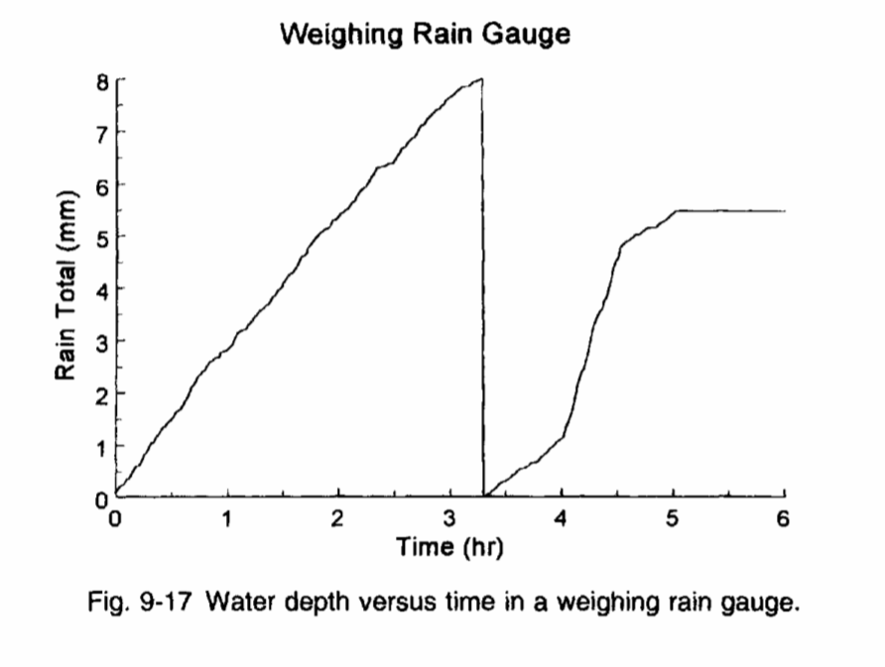

1. This output graph for a weighing rain gauge shows the total mass of water collected in this time period (~ 10 hours) to be 284 g. If the gauge has a radius of 10 cm, what rain depth (or height) was collected (in mm)? State your assumptions (i.e. regarding temperature). **/4**

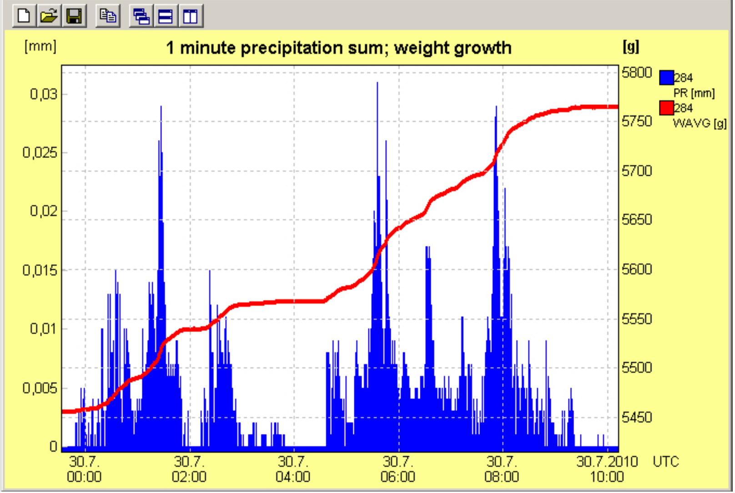

**Datalogger Programing Questions**

* ***Look at the CRBasic program below. Answer questions P1-P7 which appear in the datalogger program.***

'P1: What is the purpose of this section? Why are these lines placed at the top of the program, instead of later on? **/2**

Public Batt_Volt

Public DT

Public TCDT

Public AirTemp

Public AirTempK

Units Batt_Volt=Volts

Units DT=Metres

Units TCDT=Metres

Units AirTemp=degC

Units AirTempK=K

'-------------------------------------------------------

'P2: What does the “-1” argument mean in the DataTable function? **/1**

‘P3: What is the storage FREQUENCY in this data table? **/1**

DataTable(SnowDepth,True,-1)

DataInterval(0,10,Sec,10)

Sample(1,DT,FP2)

Average(1,DT,FP2,False)

Sample(1,TCDT,FP2)

Average(1,TCDT,FP2,False)

Sample(1,AirTempK,FP2)

Average(1,AirTempK,FP2,False)

EndTable

‘P4: Why do we bother recording the minimum battery voltage? Why don’t we include this variable in the previous data table (above, called “SnowDepth”)? **/2**

DataTable(BatteryVoltage,True,-1)

DataInterval(0,1440,Min,10)

Minimum(1,Batt_Volt,FP2,False,False)

EndTable

BeginProg

Scan(2,Sec,1,0)

Battery(Batt_Volt)

‘P5: What does the function below do? What are the normal output units of ‘VoltDiff? Does this match the units of the variable that VoltDiff is writing to, ‘and if not, what is being done to convert from the output units of VoltDiff to ‘the variable’s units? **/3**

VoltDiff(AirTemp,1,mV2500,1,True,0,_60Hz,0.1,-50)

‘P6: What does the line of code below do? Why do we need to work in the units of ‘AirTempK, instead of AirTemp? **/2**

AirTempK = AirTemp + 273.15

‘P7: What does the function SDI12Recorder do? What does the fourth ‘argument mean?‘ **/2**

SDI12Recorder(DT,1,"0","M!",1.0,0)

TCDT=DT*SQR((AirTempK/273.15))

CallTable(SnowDepth)

CallTable(BatteryVoltage)

NextScan

EndProg

**Appendix A – Wiring details for Campbell Scientific sonic ranging and temperature sensors**

Wiring for CS sonic ranging sensor, ***IN THIS ORDER***:

* Black – Ground (G, power reference)
* Red – 12V power
* Green – Control port (Cx)
* White – Ground (G)
* Clear – Shield (signal ground)

Wiring for CS temperature and humidity sensor:

* Brown – Diff channel 1H
* Blue – Diff channel 1L
* White – Diff channel 2H (not needed for this lab)
* Jumper to blue – Diff channel 2L (not needed for this lab)
* Grey – Ground (power reference)
* Green – 5V power
* Clear – Shield (signal ground)